Valentines Papel Picado
By Heidi Proffetty

Share a little love with this sweet digital cutter and sewing machine Valentine’s Day project. Did you know that stringing up Papel Picado flags in your home can be a reminder to celebrate affection and the joys of living? Papel Picado is a name given to a Mexican folk art where originally decorative flags were meticulously hand cut out of 30-40 layers of tissue paper (china paper) using chisels and hammers. Each flag depicted intricate details depending on the intended celebration. A tradition that is still carried on today. These beautiful flags are hung as colorful decorations across buildings, altars and streets to celebrate secular, religious and other special celebrations in Mexico and in other countries. In honor of this love-filled holiday, using this design created in the Simple Cut software along with the Artistic Edge digital cutter and your Janome sewing machine you can create your own delicately detailed flags out of fabric to celebrate the joys of life and love.
Skill Level: Beginner/Intermediate Pattern Makes: 1 Flag

Project Supplies:
Assorted red and pink batik fabrics (dimensions 15” x 10” for each flag)
Assorted Colors of red and pink Embroidery Threads
Steam-a-Seam Lite 2
Baker’s twine (red & white stripe)

Digital Cutter Equipment & Accessories:
Janome Artistic Edge Digital Cutting Machine
Simple Cuts Software (version 7.1 build 2017.8661)
High tack cutting mat
Tweezers
Mat Scraper
Yellow cap blade (blade for cutting fabric)
Yellow Blade Depth Setting: 3.5-4, Number of Passes: 1
Sewing machine

Note: If you prefer to make this project without the use of a digital cutter, you would need to cut the details using a precision knife blade, fine scissors and the template for this project.

Part 1 – Importing the Existing Digital Cut File Design
Open the Simple Cut Software, Select existing file, then browse to where you stored the downloaded Valentine’s Papel Picado cut file. Then using the Simple Cut software prepare to cut the design as described in my previous Janome Maker project tutorials. Visit: https://www.janome.com/inspire/projects/ or https://www.heidiproffetty.com/tutorials

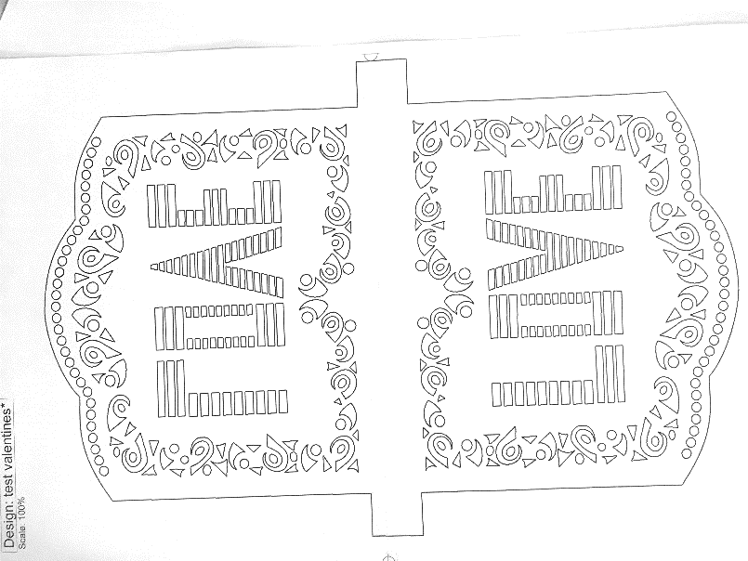

Part 2 – Preparing the Materials for Cutting
- Using the dimensions for each flag shape cut applicable amounts of fabric and Steam-a-Seam Lite 2. Suggested Dimensions (15” L x 10” W).
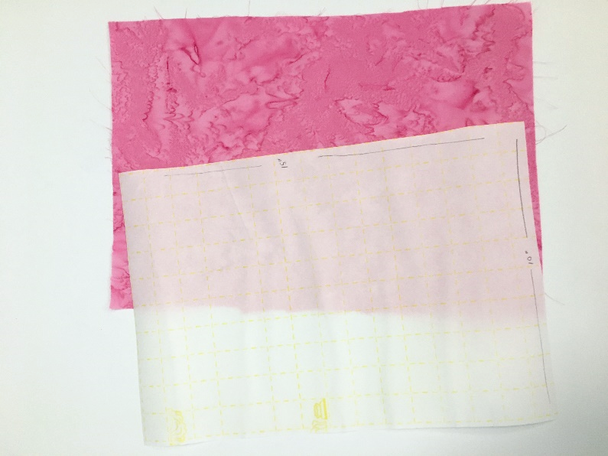

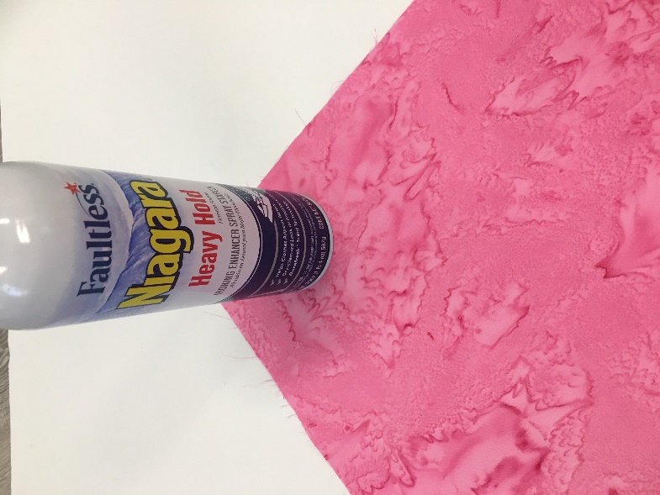
- Prepare fabric using Spray Starch.

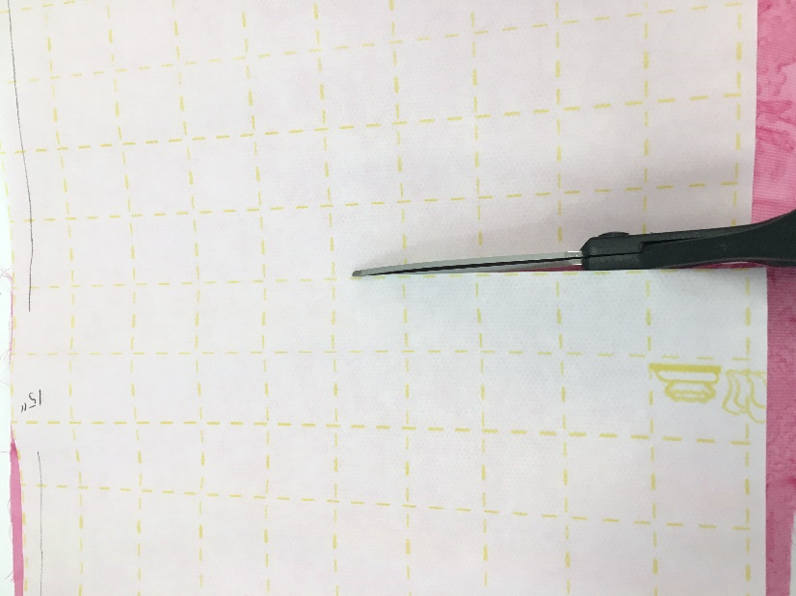
- Prepare and apply the adhesive. Using the gridlines on the Lite Steam a Seam 2 adhesive, at the 8” inch mark (center of adhesive) cut away a 1” by 8” center section of the adhesive exposing just the fabric in that section.
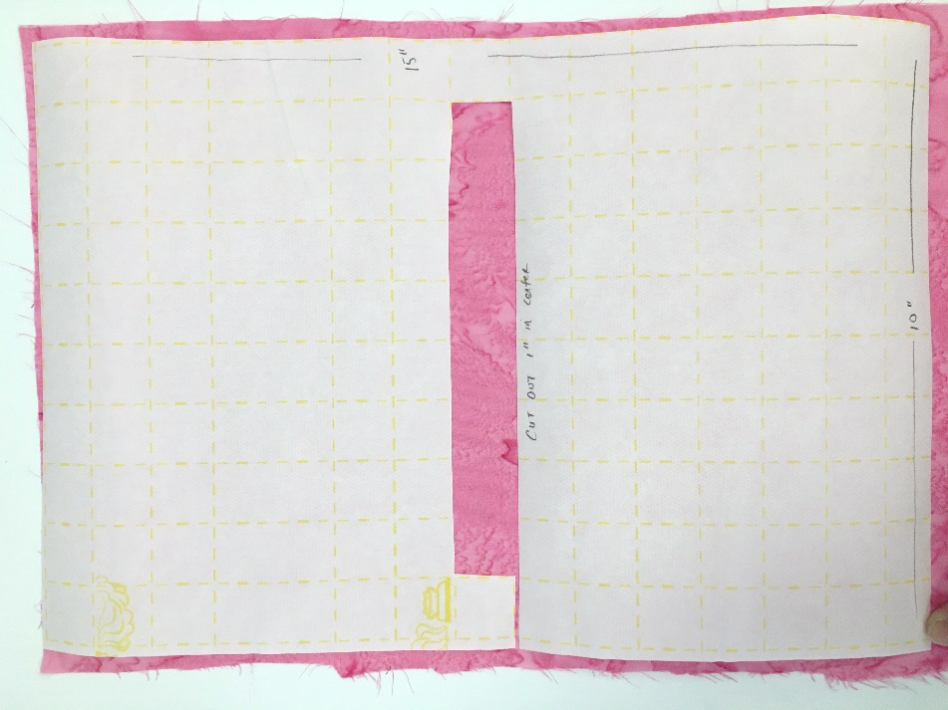
- Following instructions, adhere Lite Steam-a-Seam 2 to the backside of the fabric. Once adhered & cooled, peel away the paper exposing the adhesive.

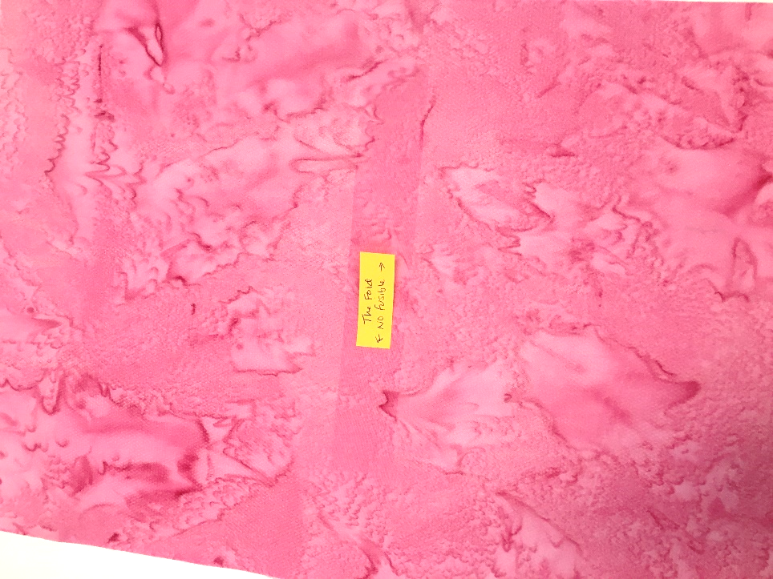
Part 3 – Cutting the design using the Digital Cutter
- Using the provided valentine’s cut file and your digital cutter, cut the double sided flag design from your prepared fabric. Choose the appropriate cutter preset settings: fabric backed with fusible, use the yellow blade, and the recommended blade settings as noted above.

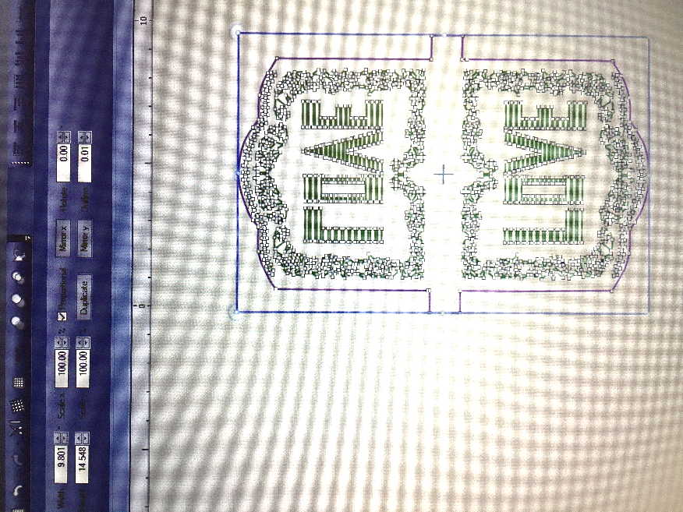

- Gently lift and remove each flag design from the cutting mat. Discard leftover bits on the cutting mat.

Part 4 – Preparing Each Flag
- Gently fold in the 1” tabs on the right and left sides of each flag to the edge of the flag.

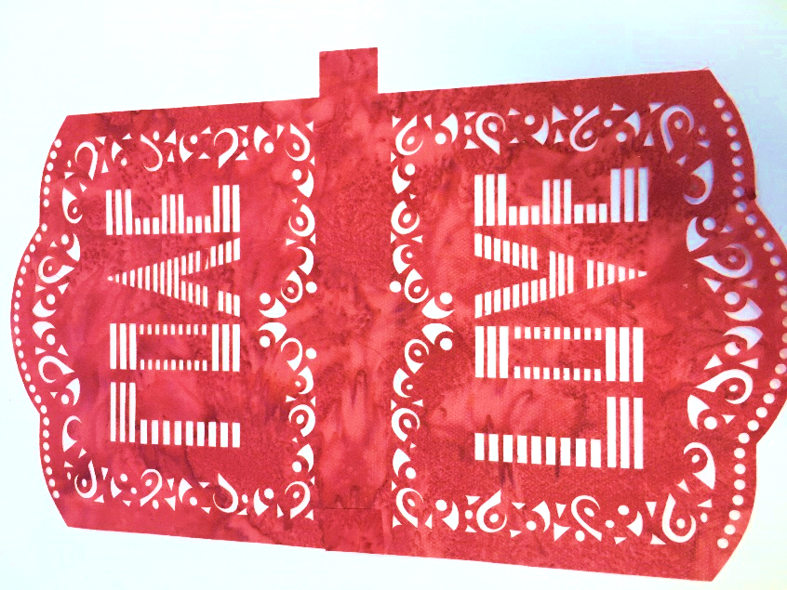

- Using an awl, to poke out any remaining stuck fabric pieces.
- 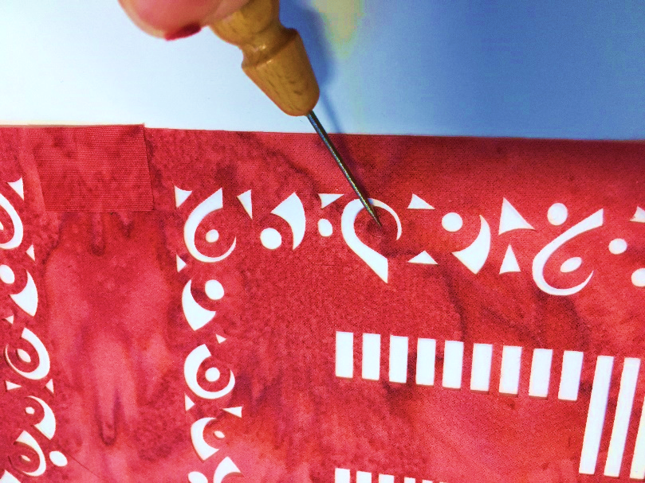
- Carefully, fold the flag in half, adhesive side to adhesive side. Taking time to match up the open spaces of the design. Repeat the above steps to make multiple flags.
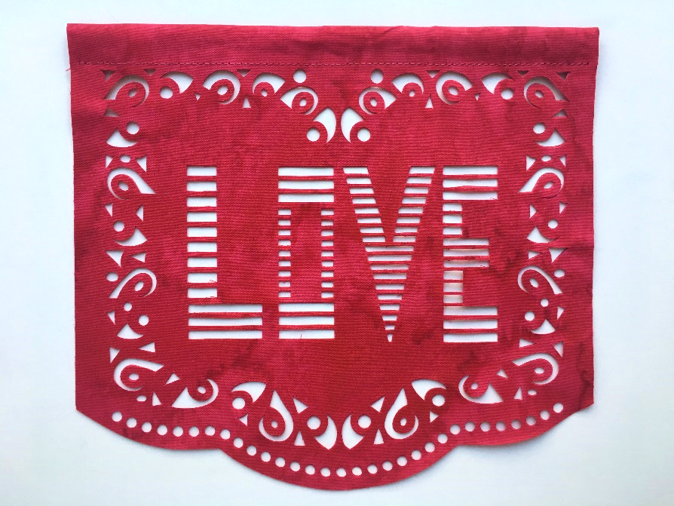
Part 4 – Sewing the Tunnel for each Flag
Once all of your flags have been assembled, you will need to create a tunnel to pass your string through for hanging.
- Using your sewing machine, sew a straight stitch approximately ¾” from the top of the flag, locking your stitch at the beginning and end to secure.
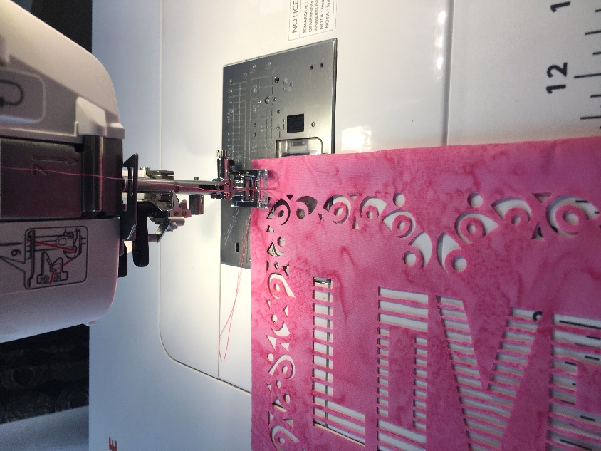
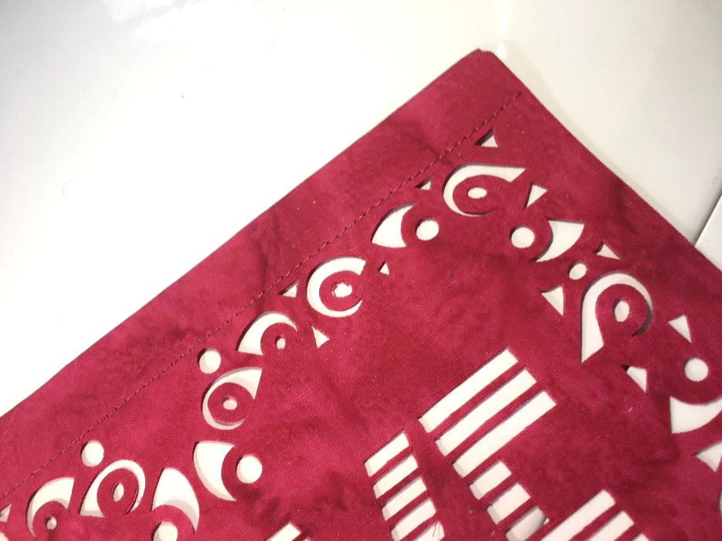

Part 5 – Finalizing your Papel Picado Flags

- Cut the desired length of string or twine. I like to use red and white baker’s twine. Then using a safety pin, pass the twine though the tunnel of each flag.

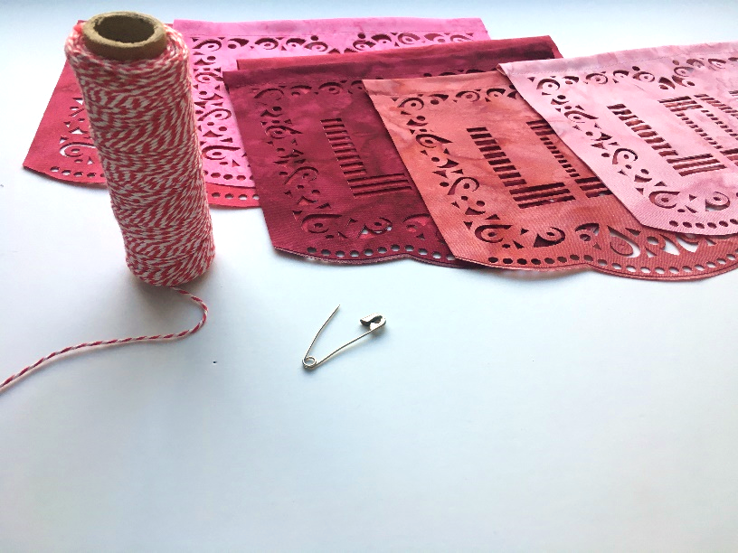
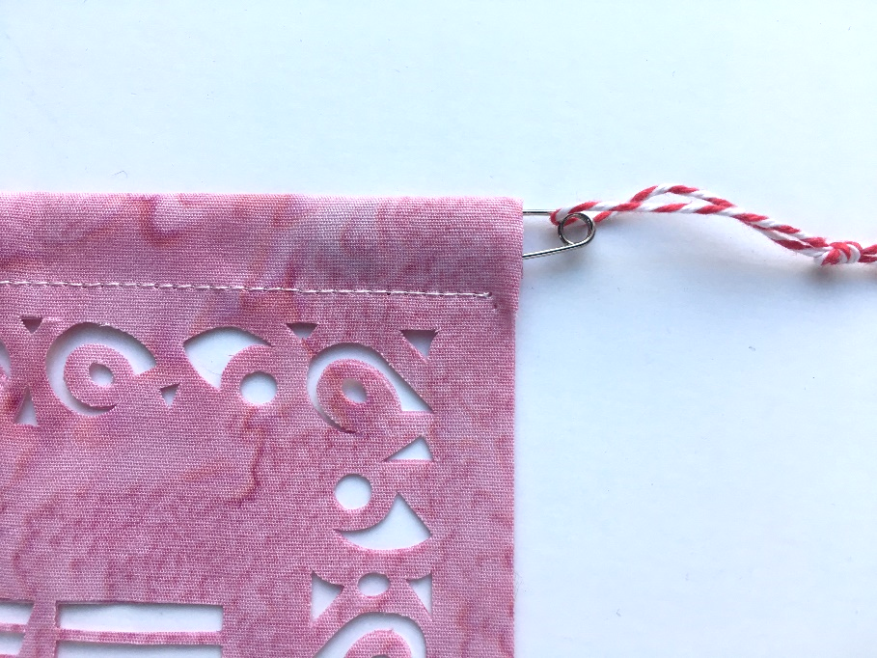

Part 6 – Hang & Enjoy your Valentine’s Papel Picado Flags!

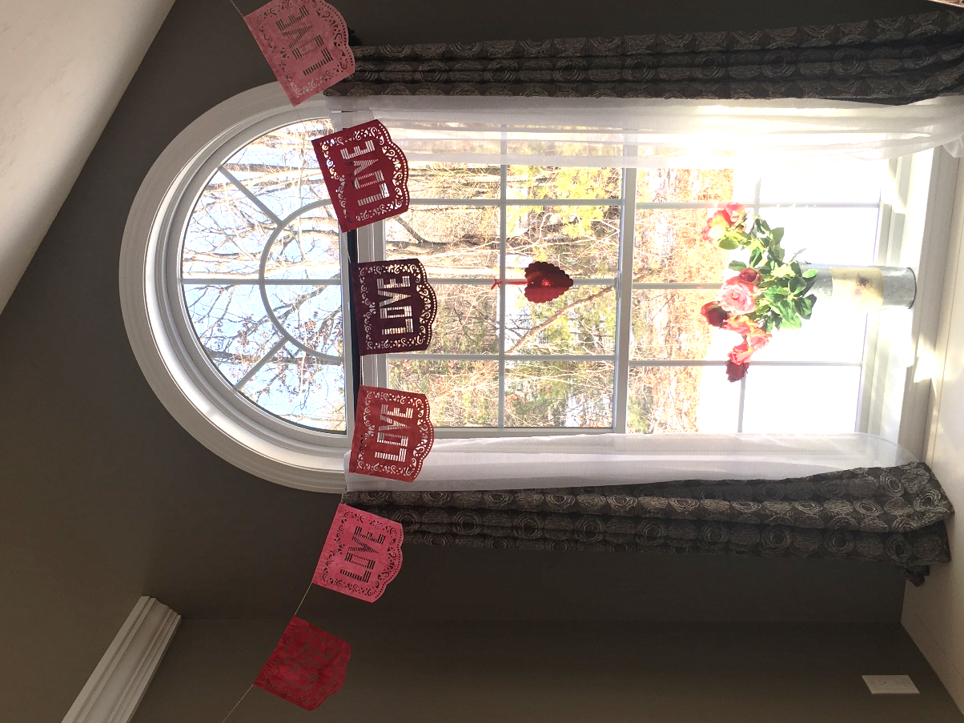

URL Address for PDF pattern.
https://static.wixstatic.com/media/3c316a_585909d1c9dd4bf78d6df6f7078d21f5~mv2.jpg

